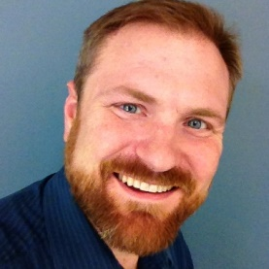

*Insert list of volunteer involvement and associated years here.*

*Legacy Task Force 2016, 2017*

2009

2010

Chair

J.J. Acker

Utah