September 23, 2019

Patty Morgan
Administrator
National CPM Consortium
P. O. Box 2133
Boise, ID 83701-2133

Dear Ms. Morgan,

In accordance with the Standard Operating Procedures Manual of the National Certified Public Manager Consortium Section 1.4.2.2, I request a continuing accreditation review of the Alabama Certified Public Manager® program in 2020. Please do not hesitate to contact me at (334) 244-3031 if I can be of further service.

I understand this request will be included in the 2019 Annual Meeting Agenda for Board Approval. I also understand that our reaccreditation review fee of $1,200 must be paid prior to that vote to be eligible.

Sincerely,
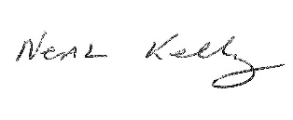
Neal Kelley
Program Director
Alabama CPM Program
(334) 244-3031
Neal.kelley@aum.edu

