October 19, 2022

Marci Porter Campbell
Chair, National Certified Public Manager® Consortium
Carl Vinson Institute of Government
201 N. Milledge Avenue
Athens, GA 30602

Dear Marci,

This letter is to formally request that the National Certified Public Manager Consortium appoint a committee to review Georgia’s Certified Public Manager Program for purposes of reaccreditation in 2023.

We anticipate hearing from the committee regarding specifics concerning the site visit and look forward to working with the committee members.

Sincerely,
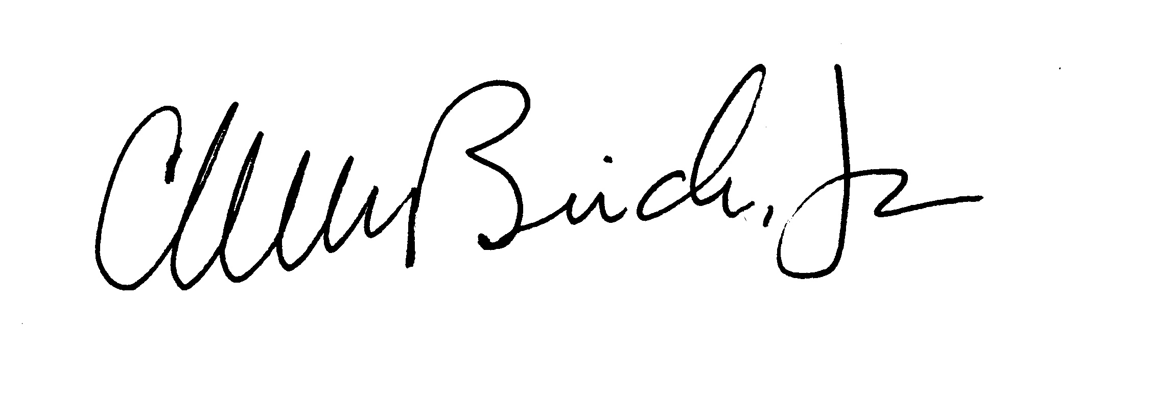
Walt McBride
Leadership Development Unit Manager

