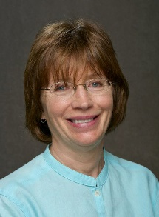

*Insert list of volunteer involvement and associated years here.*

2004

2005

Chair

Robbi Dreifuerst

Wisconsin