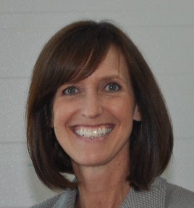

*Insert list of volunteer involvement and associated years here.*

*Legacy Task Force 2016, 2017*

2013

2014

Chair

Sherry Saracino

Utah