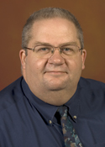

*Insert list of volunteer involvement and associated years here.*

*Executive Council Member at Large*

*Secretary 2014 2015*

*International Committee Chair 2014-2017*

*Strategic Visioning Chair 2016*

*Chair-elect 2015 2016*

*Legacy Task Force 2016, 2017*

*Nominating Committee Chair 2018*

2016

2017

Chair

Charles “Chip” Taylor

Indiana