

College of Sciences and Humanities Muncie, Indiana 47306-0005

Department of Political Science Phone: 765-285-8760

October 27, 2021

Patty Morgan

Administrator

National CPM Consortium

P. O. Box 2133

Boise, ID 83701-2133

Dear Ms. Morgan:

In accordance with the Standard Operating Procedures Manual of the National Certified Public Manager Consortium , we request a continuing accreditation review of the Indiana Certified Public Manager® program in 2022.

We understand that this request will be included in the 2021 Annual Meeting Agenda for Board Approval and we are prepared to support the reaccreditation process including the required fees. Thank you for your consideration.

Sincerely,

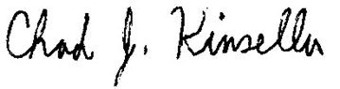

Chad Kinsella, Ph.D., MPA, MA

Associate Professor of Political Science

Managing Director of the Bowen Center for Public Affairs

Department of Political Science

North Quad Building, Office

Muncie, IN 47306

(765) 285-8790

cjkinsella@bsu.edu