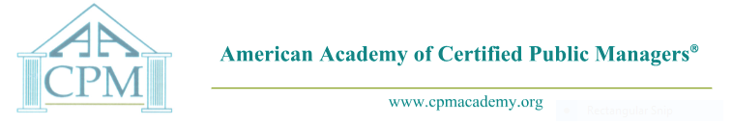

BOARD OF DIRECTORS
Proclamation
To recognize the 2021 Graduates of the
New Hampshire CPM Program

Whereas, The vision of Dr. Kenneth Henning, father of the Certified Public Manager® (CPM) concept is that all who achieve the designation of CPM shall seek to demonstrate professionalism in the public sector by providing dynamic leadership, maintaining high ethical standards, and providing hope through innovation while continuing to serve the public interest far beyond the call of duty; and

Whereas, Self-motivation by these graduates to serve their agency, their fellow employees, and the Public has sustained them during their pursuit of the knowledge, skills, and abilities to enable them to achieve success; and

Whereas, These graduates have completed rigorous study in management sciences through the Certified Public Manager® program administered by the NH , Division of Personnel, Bureau of Education and Training and accredited by the National CPM Consortium; and

Whereas, These graduates are joined today by family, friends, employers and co-workers, many of whom have played a role in this achievement and have come today to celebrate their accomplishment; and

Whereas, The American Academy of Certified Public Managers® offers these graduates who become members of the Academy the ability to network nationally with CPMs who share their professional challenges and CPM training experiences, as well as sharpen their skills by attending professional development conferences and other events, in addition to the opportunity to give back by mentoring others; and

Whereas, The AACPM Board joins all those present in the recognition of these members of the 2021 Graduating Class of the New Hampshire Certified Public Manager® Program;

Now, Therefore, the Board of Directors of the American Academy of the Certified Public Managers® invites all present on this 25th day of June, 2021, to join in the recognition of these graduates as the newest members of the national Brother and Sisterhood of Certified Public Managers®.

Gregory D. Hyland, CPM
P
President of the American Academy of Certified Public Managers

Gregory D. Hyland, CPM
PRESIDENT
Arizona
greghyland.cpm@yahoo.com

Jana Huffaker, CPM
PRESIDENT-ELECT
Idaho
Jana.Huffaker@dhr.idaho.gov

Amber E. Ortiz, CPM
SECRETARY
Idaho
Amber.Ortiz@Idaho.Tax.gov

Debbie J. Smith, CPM
TREASURER
ATWS1731@GMAIL.COM

Dennis Martino, CPM
PAST PRESIDENT
New Hampshire
dennismartino@gmail.com

Becky Bryant, CPM
MEMBERSHIP CHAIR
abbryant70@windstream.net

Tracy Watterson, CPM
DIRECTOR, EDUCATION
Vermont
Tracy.Watterson@Vermont.gov

AACPM ADMINISTRATOR

Patty Morgan
Idaho
800-318-2810
patty@cpmacademy.org

