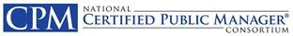
The Organization’s Accomplishments
From the Chair
• • •

I was fortunate to serve as Chair in 2005 as the Consortium marked the 25th Anniversary of its founding. A trip down memory lane for some, a great history lesson for others. CPM pioneers Susan Paddock (WI) & Sam Breen (LA) co-emceed the festivities. A good time was had by all!
We were a much smaller group back then, 26 Accredited programs and 3 Associates. Oh, how we’ve grown!
A Year in the Story of NCPMC
Robbi Dreifuerst, Chair | 1/1/2005 | Jack Lemons, Administrator

  - Key Initiatives in 2004-2005

General Board Business
- Celebrated the Consortium’s 25th Anniversary in Manchester, NH
- California and the US Virgin Islands became Associate Members of the Consortium.
- Constitution amended to add “... and its territories” to include USVI.
- Adopted the Competency-based Model for program curriculum.

Committees/Goal Teams
- Executive Council Job Descriptions developed and added to the SOPs
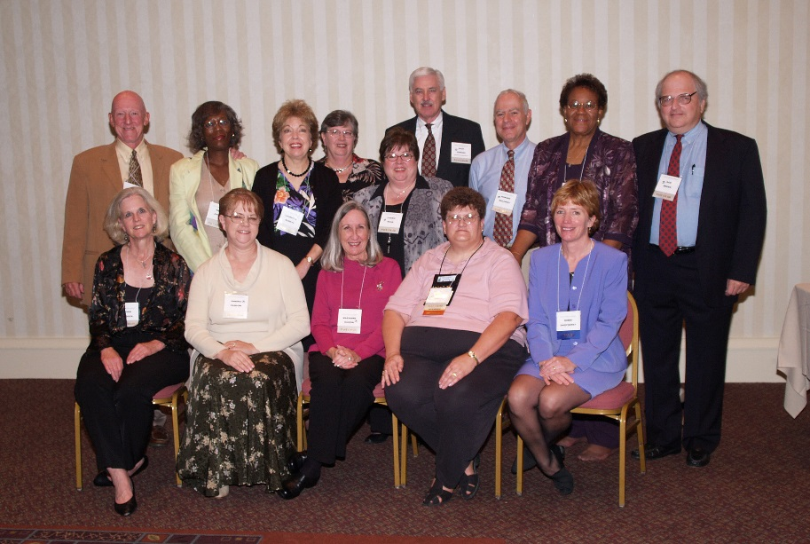
Consortium Chairs 1981-2005 who attended the
25th Anniversary Celebration - Sept 18, 2005 – Manchester, NH

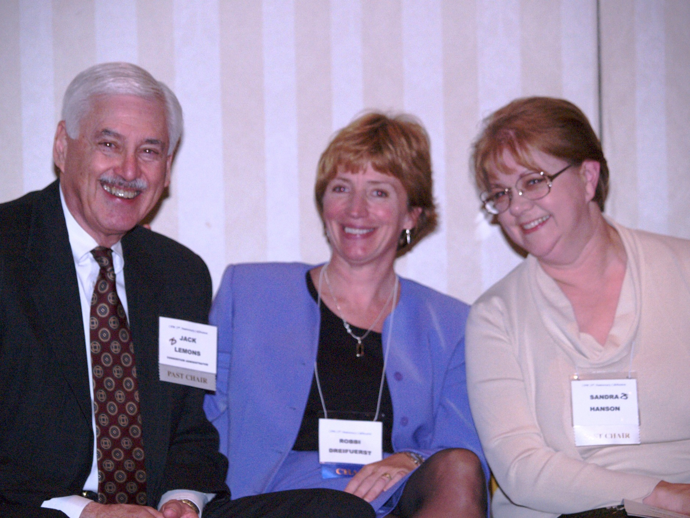
Two of my biggest supporters during my term... Jack Lemons, administrator extraordinaire, and Sandy Hanson, Arkansas, my predecessor as chair.

NCPMC
2016 Annual Meeting
Baltimore, Maryland

