The Organization’s Accomplishments
A Year in the Story of NCPMC
Sherry Saracino | 2013-14 | Peggy Stewart, Administrator

From the Chair
• • •
During my year as chair, the board continued to focus on productivity and growth, both internally and externally.
I was honored, challenged, and a little scared to serve as a member of the Executive Council of NCPMC from 2011 through 2014. What a huge responsibility! Together we experienced the change of administrators from Jack Lemon to Peggy Stewart, saw programs excel and struggle, realized we needed to “up our game” and that our financial situation could not sustain the needed impacts of such, recognized that our national program was being sought after in other parts of the world and we needed to take a unified stance, and that to not only survive but excel as an organization we needed to become more productive throughout the year.
Thanks to all of the NCPMC members for allowing me the opportunity to be a part of this outstanding organization.

  - Key Initiatives in Year

General Board Business
The NCPMC continued to work toward accomplishing more committee work and consortium business regularly throughout the year. Online officers and executive council meetings and frequent contact with work groups increased communication between, and productivity of, the council, goal teams, task forces and individual members.

Democratic Rules of Order for meeting management was implemented.

The revenue stream was identified as a too low to sustain the large body and number of projects needed to advance the NCPMC. A new budget including dues increases, a raise
for the administrator, and money earmarked for certain projects was passed.

After several years of consideration, ASPA voted to endorse the CPM programs and future collaboration with ASPA was put on the table for consideration

It was noted that AACPM was struggling to survive after merging with ASPA. There was a deep drop in membership, and their future at this point was unknown.

Committees/Goal Teams
The Governance Committee completed a major review and realignment of our Constitution and Bylaws. SOPs were still undergoing updates.

Improving Operations continued to work on improving communications and made recommendations which were approved by the board for provide long term financial viability.

Task Force Work Completed
An International Programs task force was created to inform a policy recommendation regarding possible international CPM certification. Initial findings were reported at the annual meeting, and committee was tasked to continue its work

An ASPA Partnership Task Force reported on areas of concern and positivity regarding a possible relationship or alliance with ASPA.

NCPMC
2014 Mid-Year Meeting
Washington, DC
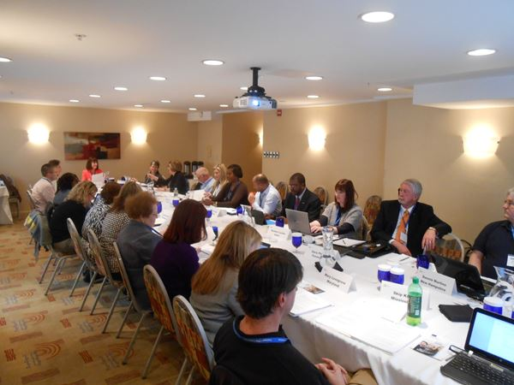
When Utah hosted the AACPM Conference and NCPMC annual meeting in 2011, the NCPMC secretary could not attend and I was asked to take minutes. I was officially voted as secretary for the 2011-12 board immediately after. No good deed goes unpunished they say!
Photo of NCPMC
2014 Annual Meeting
San Diego, CA
I’m hoping someone (has Peggy / Tom been contacted regarding photos?) has a photo from the 2014 Annual meeting in San Diego

